**PROJECT REPORT**

**"Deep Learning Approaches for Enhanced American Sign Language Recognition"**

1. **Team Details**

|  |  |  |  |  |
| --- | --- | --- | --- | --- |
| Name | Roll No | Class | Email Id | Contact |
| Jammisetty Sai Nanda Gopal | 2K21CSUN04014 | B Tech CSE AIML 6A | Sainandagopal09@gmail.com | 9381615631 |
| Vemisetti Srinish | 2K21CSUN04037 | B Tech CSE AIML 6A | Srinish183@gmail.com | 6302908424 |

1. **Supervisor Details**

|  |  |  |
| --- | --- | --- |
| Name | Designation | Department Name |
| Dr. Parneeta Dhaliwal | Professor | Computer Science and Technology |

## **Introduction**

In an age defined by technological advancement, our project delves into the realm of deep learning and transfer learning to tackle the pressing challenge of American Sign Language (ASL) recognition. With the overarching goal of enhancing accessibility and communication for individuals with hearing impairments, our endeavor focuses on developing sophisticated models capable of accurately deciphering ASL gestures from image data. By leveraging Convolutional Neural Networks (CNNs) and transfer learning techniques, we strive to create robust systems adept at real-time interpretation of ASL signs. Through the utilization of cutting-edge frameworks like TensorFlow and Keras, we aim to bridge the gap between ASL communication and technological innovation, fostering inclusivity and empowerment within our communities. Our project stands at the intersection of AI and accessibility, poised to revolutionize the landscape of assistive technologies and pave the way for a more inclusive society.

1. **Scope**

The project entails the development and implementation of deep learning models, primarily CNNs, to recognize and interpret ASL gestures from image data.

1. **Data Collection and Preprocessing**: It involves sourcing and curating a comprehensive dataset of ASL images, followed by preprocessing tasks such as resizing, normalization, and data augmentation to ensure model compatibility and performance.
2. **Model Construction and Training:** The project encompasses the construction of CNN architectures tailored for ASL recognition tasks, along with training procedures to optimize model parameters and enhance accuracy.
3. **Transfer Learning Exploration:** Additionally, the project explores transfer learning techniques, leveraging pre-trained models such as ResNet50 to enhance ASL recognition performance, particularly in scenarios with limited training data.
4. **Evaluation and Performance Analysis:** A crucial aspect of the project involves rigorous evaluation of model performance using metrics such as accuracy, loss, and validation scores. Comparative analysis between different model architectures and methodologies is conducted to identify strengths and weaknesses.
5. **Visualization and Reporting:** Comprehensive visualization of model training dynamics, performance metrics, and comparative analyses is conducted to provide insights into the efficacy of different approaches. Results are documented in detailed reports to disseminate findings and contribute to the body of knowledge in ASL recognition and assistive technology development.
6. **Future Extensions and Applications:** The project sets the stage for potential future extensions, including the development of mobile applications, web-based interfaces, and wearable devices capable of real-time ASL interpretation, thereby expanding the scope of accessibility solutions for the hearing-impaired community.
7. **Requirement, specification and methodology**

The project's requirements entail gathering a diverse dataset of American Sign Language (ASL) images, employing a GPU-equipped system with Python, TensorFlow, and Keras for efficient model development. Preprocessing tasks involve resizing, normalizing, and augmenting images to enhance dataset quality and model robustness. Model construction focuses on designing and customizing Convolutional Neural Network (CNN) architectures for ASL recognition, with potential exploration of transfer learning techniques. Training and evaluation processes include assessing model performance using metrics like accuracy and loss, validated on separate sets. Real-time integration aims to implement ASL interpretation, possibly deploying models on edge or cloud platforms for practical use. Evaluation metrics ensure models meet real-world usability standards, while optimization strategies aim to improve performance and efficiency in real-time interpretation. Comprehensive documentation of the entire process, including dataset details, model architectures, training procedures, and evaluation results, is prioritized. Future extensions may include mobile deployment, multi-gesture recognition, and user interface development to broaden accessibility impact.

1. **Timeline**

**Research Proposal and Planning:**

* + Define the scope and objectives of your review.
  + Conduct a literature review to identify existing research
  + Formulate research questions.
  + Determine the research methodology and data sources.

**Data Collection and Preprocessing:**

* + Gather relevant datasets related to crop recommendation.
  + Clean and preprocess the data, including data cleaning, feature selection, and data transformation.

**Literature Review:**

* The literature review examines existing research on ASL recognition, highlighting advancements in deep learning, CNN architectures, and transfer learning techniques.
  + It provides insights into model performance, dataset diversity, and real-world applications, informing the project's methodology and objectives.

**Model Selection and Development:**

* + Model selection involves designing CNN architectures tailored for ASL recognition, potentially incorporating transfer learning methods for enhanced performance.
  + Development focuses on training and optimizing chosen models using diverse ASL datasets, ensuring robustness and accuracy in gesture interpretation.

**Evaluation and Validation:**

* + Evaluation involves assessing model performance metrics such as accuracy, precision, and recall using held-out test datasets.
  + Validation ensures generalization of the models by assessing performance on separate validation sets, guarding against overfitting and ensuring real-world usability.
  + Compare the performance of different machine learning techniques.

**Analysis and Discussion:**

- Analyse the results and draw conclusions.

1. **Screenshots**

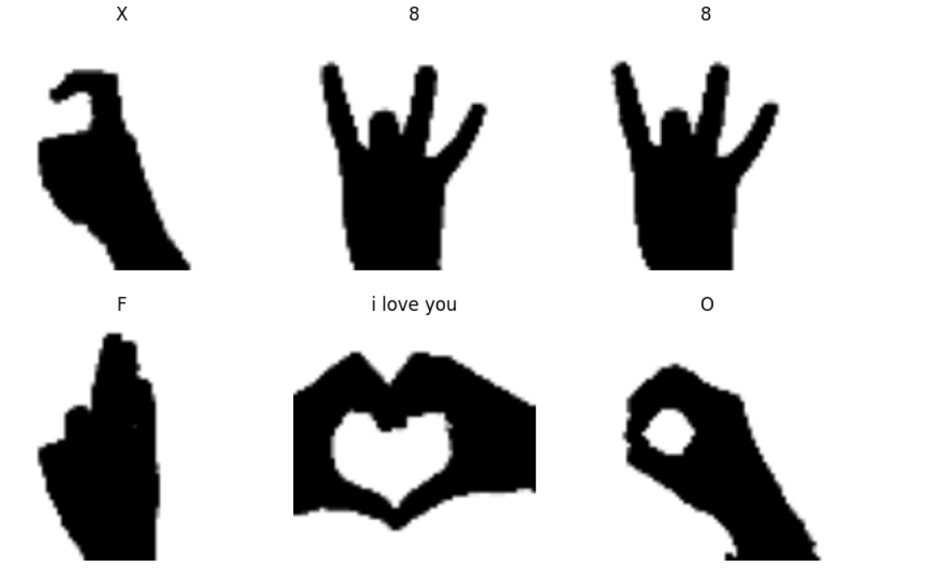

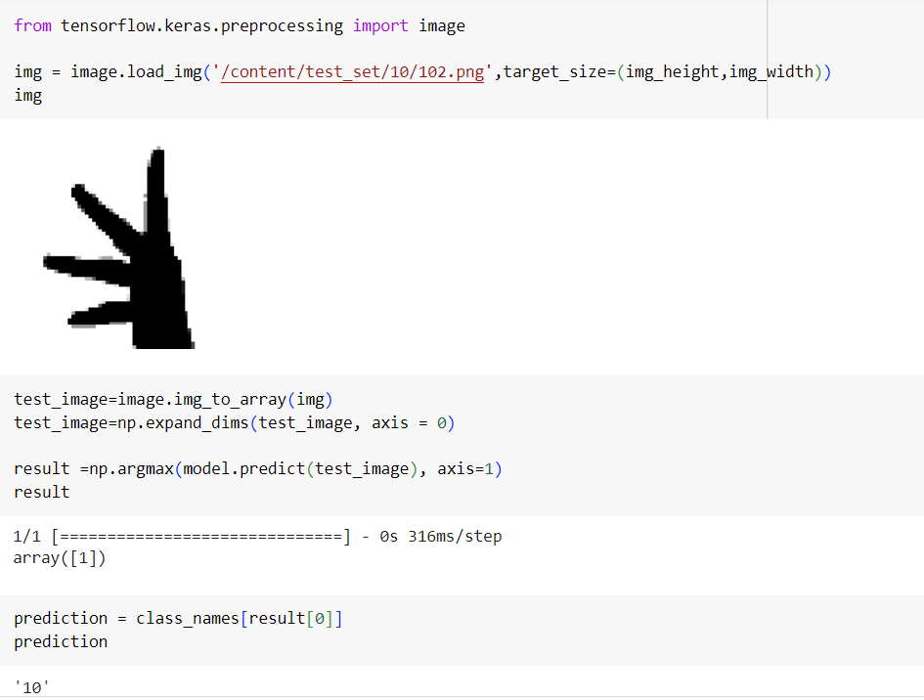

**Fig: Output of Image showcasing the Symbol**

1. **Future Enhancement**

Future enhancements may include deploying models on mobile platforms for on-the-go accessibility, expanding recognition capabilities to encompass multi-gesture sequences, and integrating user-friendly interfaces for broader adoption and usability in real-world scenarios.

1. **Outcomes**

The outcomes of the project include the successful development of robust deep learning models capable of accurately recognizing American Sign Language (ASL) gestures from image data. These models demonstrate high accuracy and real-time performance, facilitating seamless communication and accessibility for individuals with hearing impairments. Additionally, the project contributes to the advancement of assistive technologies by providing insights into effective model architectures, training methodologies, and potential avenues for future enhancements. Through comprehensive evaluation and validation, the project ensures the reliability and usability of the developed models in practical scenarios, ultimately fostering inclusivity and empowerment within society.